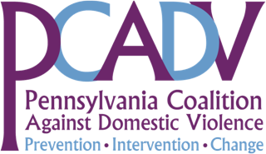

Sampling of Nuisance Ordinances in Municipalities Across Pennsylvania
October 2013
City/Municipality | County | Copy of Ordinance on File with PCADV
1. Allentown | Lehigh | No
2. Borough of Berwick | Columbia | Yes
3. Borough of Coaldale | Schuylkill | No
4. Borough of Colwyn | Delaware | No
5. Borough of Forest City | Susquehanna | Yes
6. Borough of Mahanoy City | Schuylkill | Yes
7. Bridgeport | Montgomery | Yes
8. Carbondale | Lackawanna | Yes
9. Carlisle | Cumberland | No
10. Ford City | Armstrong | Yes
11. Harrisburg | Dauphin | Yes
12. Honesdale | Wayne | Yes
13. Kulpmont | Northumberland | Yes
14. Lancaster | Lancaster | Yes
15. Norristown | Montgomery | Yes
16. Pitcairn | Allegheny | No
17. Pittsburgh | Allegheny | Yes
18. Pottsville | Schuylkill | Yes
19. Reading | Berks | Yes
20. Scranton | Lackawanna | Yes
21. Sunbury | Northumberland | Yes
22. Wilkes-Barre | Luzerne | Yes
23. York | York | No

Municipalities Introduced but Rejected Passing a Proposed Nuisance Ordinance

City/Municipality | County
Willamsport | Lycoming
Vandling | Lackawanna

