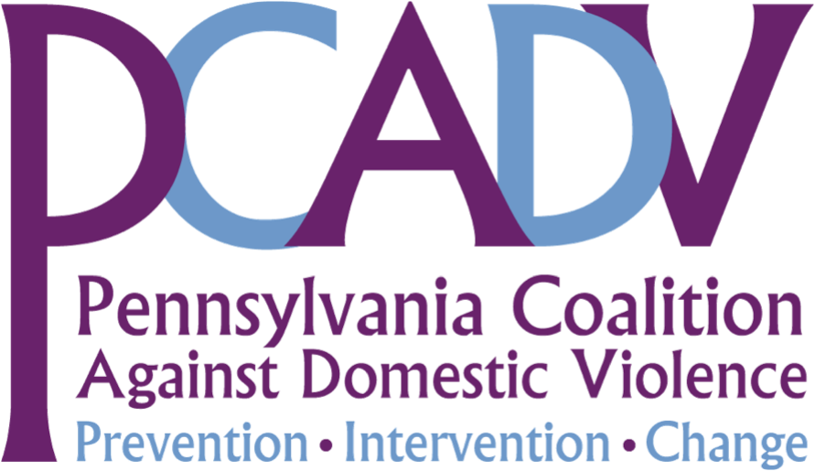

Pennsylvania Legal Aid Network, Inc.
Housing Law Group Meeting
November 19, 2013

Domestic Violence, Nuisance Ordinances and Housing
Presented by Laurie L. Baughman, Senior Attorney
Pennsylvania Coalition Against Domestic Violence

Agenda:

9:30 – 9:45 - Briggs v. Norristown
Facts
Legal arguments
Case Status
HUD Investigation

9:45 – 10:00 – Nuisance Ordinances Across Pennsylvania
Letter writing campaign
HB 1796
Nuisance Ordinances Across the Nation

10:00 – 10:15 – PCADV Technical Assistance
Overview of Attorney Toolkit

Materials on CD:
- Norristown’s Nuisance Ordinance
- Briggs v. Norristown Complaint
- PCADV Amicus Curiae Brief
- Pennsylvania Nuisance Ordinance Chart
- Vandling News Article
- Addressing Discriminatory Housing Barriers For Victims of Domestic Violence: A Toolkit for Attorneys (2013)

